Q1.
Code-
class Q1{
public static void main(String args[]){
System.out.println("Name - Dishna Daham Wijemanna");
System.out.println("Address - 30A, Malamulla West, Panadura.");
System.out.println("Phone number - 0763646095");
System.out.println("Email - dishnadahamwijemanna@gmail.com");

}
}
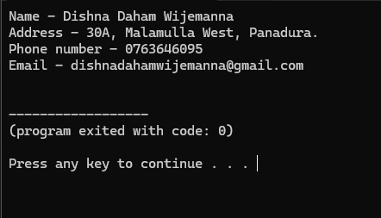

Q2.
Code-
class Q2{
public static void main(String args[]){
System.out.println("*");
System.out.println("* *");
System.out.println("* * *");
System.out.println("* * * *");
System.out.println("* * * * *");
System.out.println("* * * * * *");
System.out.println("* * * * * * *");
}
}
Output
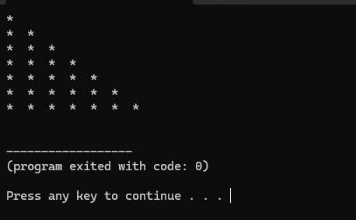
Q3.
Code-
class Q3{
public static void main(String args[]){

System.out.println(" 299");
System.out.println("+ 800");
System.out.println("-------------");
System.out.println(" 1099");
System.out.println("=============");
}
}
Output-
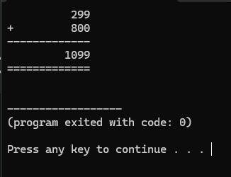
Q4.
Code-
class Q4{
public static void main(String args[]){
System.out.println("* * * * * * ==================================");
System.out.println(" * * * * * ==================================");
System.out.println("* * * * * * ==================================");
System.out.println(" * * * * * ==================================");
System.out.println("* * * * * * ==================================");
System.out.println(" * * * * * ==================================");
System.out.println("* * * * * * ==================================");
System.out.println(" * * * * * ==================================");
System.out.println("* * * * * * ==================================");
System.out.println("==============================================");
System.out.println("==============================================");
System.out.println("==============================================");
System.out.println("==============================================");
System.out.println("==============================================");
System.out.println("==============================================");
}
}
Output
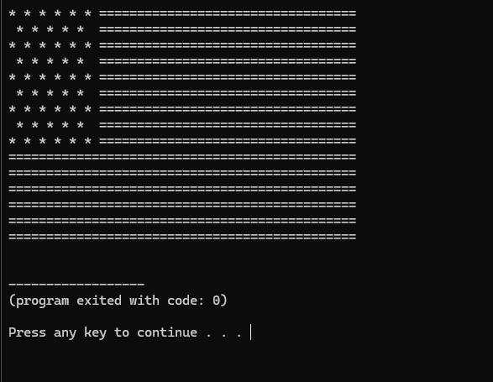
Q5A.
Code-
class Q5A{
public static void main(String args[]){
System.out.println("Institute of Computer Engineering Technology");
System.out.println("223 A,");
System.out.println("Galle Roud,");
System.out.println("Panadura.");
}
}
Output-
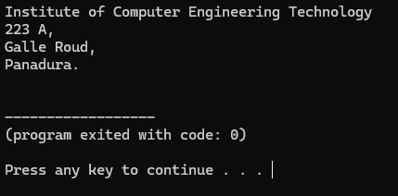

Q5B.
Code-
class Q5B{
public static void main(String args[]){
System.out.println("Institute of Computer Engineering Technology");
System.out.print("223 A,");
System.out.print("Galle Road,");
System.out.print("Panadura.");
}
}

Output-
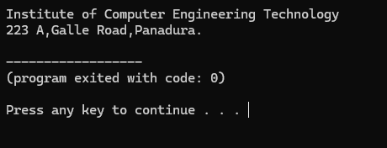

Q6.
Code-
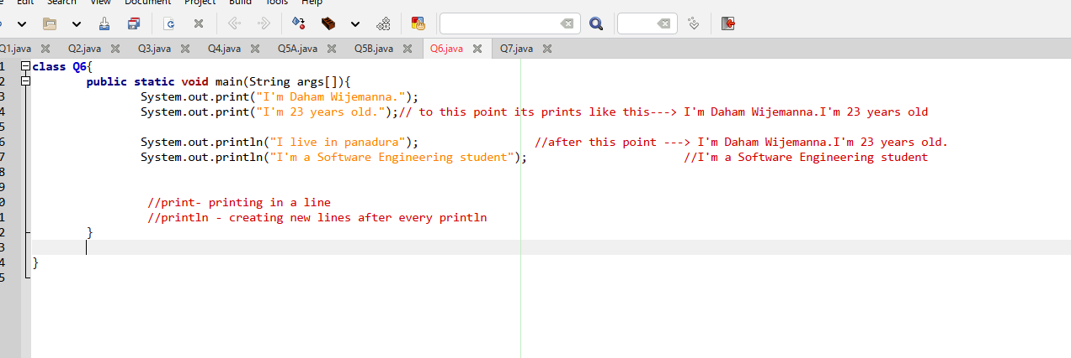

Output-

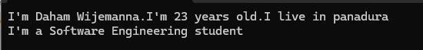

- 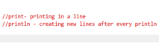

Q7.
Code-
class Q7{
public static void main(String args[]){
System.out.println("a"); //line 1
System.out.println('a'); //line 2

}

}

Output-

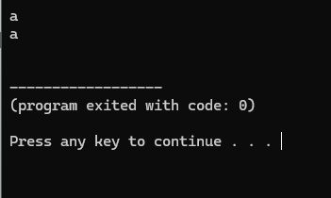

- Output is the same but different is the first (a) is a String because it has (“ ”)s.
- And second (a) is a char because it has (‘ ’)s.

Q8.
Code-
class Q8{
public static void main(String args[]){
System.out.println(7); //line 1
System.out.println(7.0); //line 2
System.out.println("7"); //line 3
System.out.println('7'); //line 4

}
}
Output –
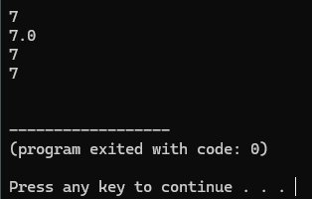

- The first 7 is an integer
- The Second 7 is a double
- The third 7 is a String
- The fourth 7 is a char

Q9.
What are the type of java literals? Explain with a suitable example.

class Q9{
public static void main(String args[]){
// 1. Integer Literals
int decimalInt = 100;
int hexInt = 0x64; // 100 in hexadecimal
long longInt = 10000000000L; // 'L' marks it as a Long

// 2. Floating-Point Literals
double piDouble = 3.14159; // Default is double
float piFloat = 3.14F; // 'F' marks it as a float

// 3. Character Literal
char letterA = 'A';

// 4. String Literal
String greeting = "Hello, Java!";
System.out.print(“hello”) //print a string literal without creating a variable

// 5. Boolean Literal
boolean isJavaFun = true;
}
}

Q10.
Code-
class Q10{
public static void main(String args[]){
System.out.println(1100100); //line 1
System.out.println(0B1100100); //line 2
System.out.println(01100100); //line 3
System.out.println(0x1100100); //line 4
}
}
Output-
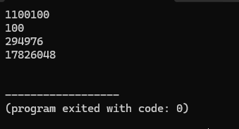
- Line1 - Since there is no prefix, Java interprets this as a standard base-10 number.
- Line2 - The prefix 0B (or 0b) tells Java that this is a binary number (base-2).
- Line3 - A leading 0 with no trailing letters indicates an octal number (base-8).
- Line4 - The prefix 0x (or 0X) specifies a hexadecimal number (base-16).

Q11.
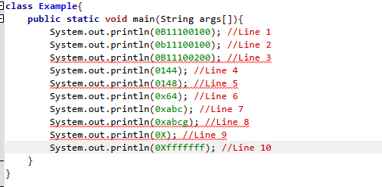

Explain -
- Line1- Binary literals in Java can start with either uppercase 0B or lowercase 0b. Every digit following the prefix is either a 1 or a 0, making them perfectly legal. valid
- Line2- I had explain it in line 1 Example . Valid
- Line3- The 0B prefix demands a binary number. Because binary numbers can only consist of 0 and 1, the inclusion of the digit 2 triggers a compile-time syntax error. Invalid
- Line4- The leading 0 designates this as an octal literal. Octal numbers use digits from 0 to 7. Because 1, 4, and 4 are all valid octal digits, this compiles cleanly (it evaluates to decimal 100). valid
- Line5 - the leading 0 indicates an octal literal. However, octal systems do not contain the digit 8 (only 0-7). Java will flag this as an integer number too large or an invalid octal digit. invalid
- Line6 & Line7 - Hexadecimal literals use the 0x or 0X prefix and can contain numbers 0-9 and letters a-f (case-insensitive). Both statements stay perfectly within those boundaries. valid
- Line 8 - Hexadecimal digits only go up to the letter f (representing 15). The letter g is not a valid hexadecimal character, causing a compilation failure. invalid
- Line 9 - You cannot provide a number base prefix (0X) without providing a value after it. The compiler expects hex digits to follow the prefix. invalid
- Line 10 - A standard Java int is a signed 32-bit value. Writing eight fs in hex fills all 32 bits with 1s (1111...1111). In two's complement binary arithmetic, this represents the value -1, which fits perfectly inside a standard Java integer. valid
Q12.
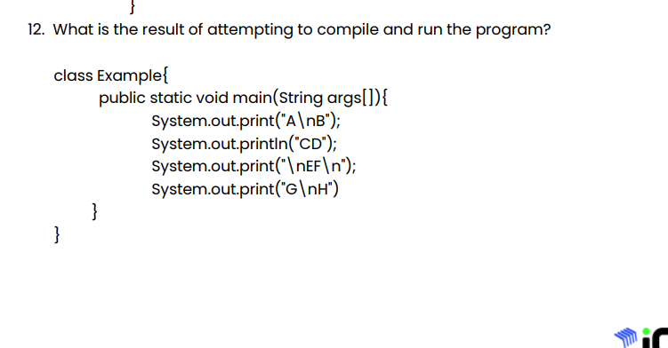

Output-

Error- syntax error (no semicolon in line 4)

Q13.
class Q13{
public static void main(String args[]){
System.out.print("i\tiCM - iCET CERTIFIED MASTER\n\nii.\tiCM\n\n\tiCET\n\tCERTIFIED\n\tMASTER\n\niii.\tiCM\n\n\tiCET CERTIFIED MASTER");
}
}

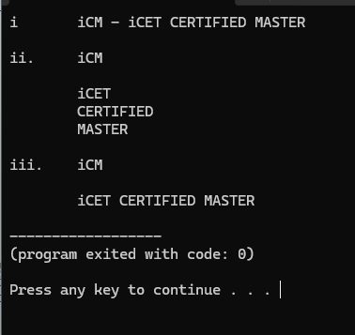

Q14.
Code -
class Q14{
public static void main(String args[]){
System.out.println("Hello\nJAVA");
System.out.println("Hello\tJAVA");
System.out.println("Hello\bJAVA");
System.out.println("\\Hello JAVA\\");
System.out.println("\"Hello\nJAVA\"");
System.out.println("\'Hello\nJAVA\'");
}
}

Output –
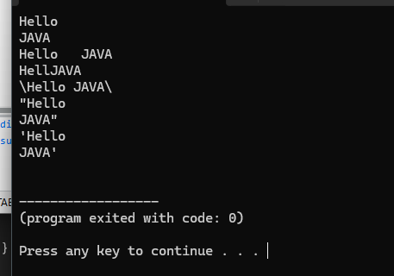
Explain
- Line 1 - The \n breaks the text , sending JAVA to the next line.
- Line 2 - The \t inserts a standard horizontal tab space between the words.
- Line 3 - The \b acts as a backspace character, which deletes the trailing letter 'o' from "Hello" before printing JAVA.
- Line 4 - Each \\ translates to a single literal backslash.
- Line 5 - Prints a double quote \" , prints Hello, snaps to a newline via \n, prints JAVA, and ends with two consecutive double quotes \"\" .
- Line 6 - Prints a single quote \', prints Hello, drops to a newline via \n, prints JAVA, and ends with a double quote \" .
Q15.
Code –
class Q15{
public static void main(String args[]){
System.out.println("a. Java is a typed language\nb. AB\"CB\nc. AB\\CD\nd. C:\\Windows\\Program\ne. AB\\\"CD\nf. AB\\\\\"\"CD\ng. AB\\nCD\nh. AB\\tCD\ni. AB\\bCD");
}
}

Output –
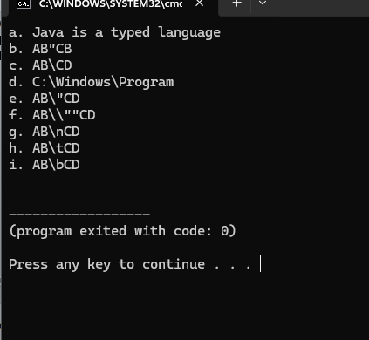

Q16.
Code –
class Q16{
public static void main(String args[]){
System.out.println(" _ _____ ______ _______ ");
System.out.println("(_)/ ____| ____|__ __|");
System.out.println(" _| | | |__ | | ");
System.out.println("| | | | __| | | ");
System.out.println("| | |____| |____ | | ");
System.out.println("|_|\\_____|______| |_| ");
}
}

Output –

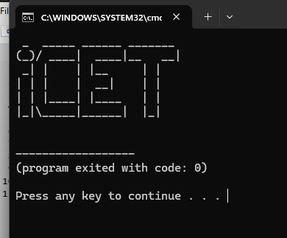

Q17.
Code –
class Q17{
public static void main(String args[]){
System.out.println(" +\"\"\"\"\"+");
System.out.println(" [ | o o | ]");
System.out.println(" | ^ |");
System.out.println(" | '-' |");
System.out.println(" +'''''+");
System.out.println(" |||||||||");
System.out.println(" /\\/\\/|||||||||||\\/\\/\\");
System.out.println(" |||||||||||||");
System.out.println(" |||||||||||||||");
System.out.println(" |||||||||||||");
System.out.println(" |||||||||||");
System.out.println(" |||||||||");
System.out.println(" /\\ /\\");
}

}
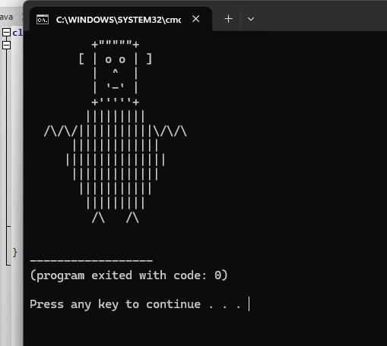

Q18.
Code -
class Q18{
public static void main(String args[]){
int i; //line 1
i=103; //line 2
System.out.println(i); //line 3

}
}

Explain -
- Line 1 – create a integer variable name “ i “
- Line 2 – Assign a 103 value to “ i ”variable
- Line 3 – print “ i ” variable

Q19.
class Q19{
public static void main(String args[]){
int x;
int y;
x = 102;
y = 103;
System.out.println(x+"\t"+y);
System.out.println(y+"\t"+x);
}
}
Output-
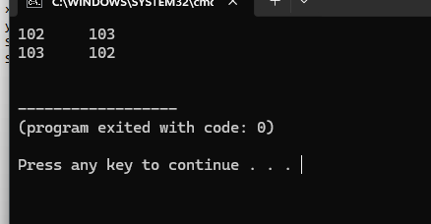

Q20.
class Example{
public static void main(String args[]){
int x;
System.out.println(x);
}
}

Answer –
- V-compile time error

Q21.
Code-
class Q21{
public static void main(String args[]){
int x=10,y=20,z=30;
System.out.println(x);
System.out.println(y);
System.out.println(z);
int y=200;
System.out.println(y);
}
}
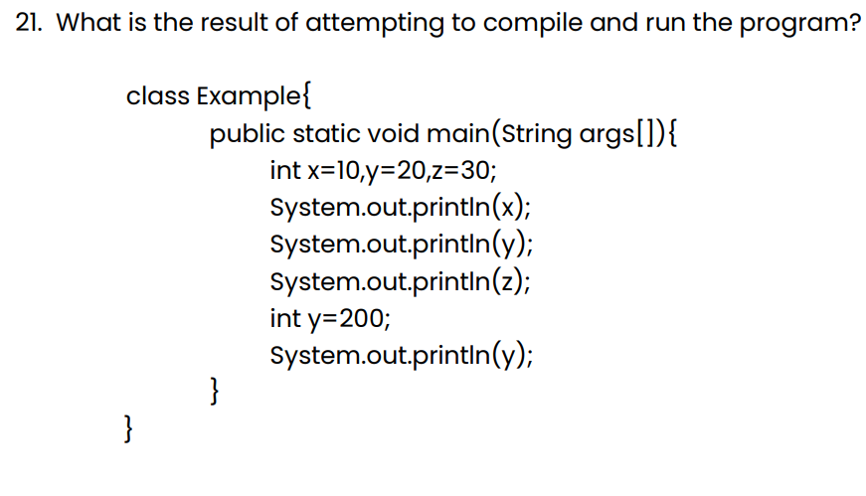
Error-
- Creating same “y” variable twice.

Q22.
Code-
public static void main(String args[]){
int x,y;
x=100;
y=200;
System.out.println(x);
System.out.println(y);
y=300;
System.out.println(x);
System.out.println(y);
}
}
Output-
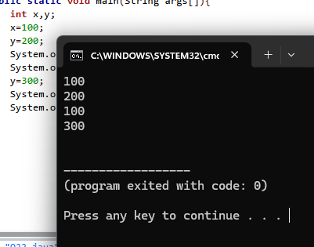
Explain-
- Line1,2,3,4,5 - and First creating x,y variable as int data type and assign value 100and 200 to each variable and print those
- Line 6,7,8 – assign a new 300 value to the y variable and prints it.

Q23.
Code-
class Q23{
public static void main(String args[]){
int x;
x =100;//line12 B
System.out.println(x);
}
}

Explain -
- A - compile error , java would not allow to do this without assign a value to a variable.
- B- correct answer , assign a value to a variable
- C-Compile error, semicolon is missing and if it add to this it still crash because of x
, because it doesn’t have a value
- D- error because it will create x variable twice
- E – error because then x didn’t have a value

Q24.
Code-
class Example{
public static void main( String args[] ){
int x,y,z; //line 1
x=y=z=10; //line 2
int a=12,b,c=4; //line 3
int p=10; //line 4
int q=p; //line 5
int i=j=k=10; //line 6
}
}
Error-
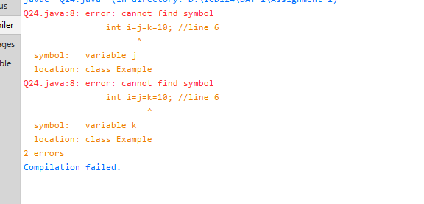

Answer- D. compile error at line 6.

Q25
Code-
class Q25{
public static void main(String args[]){
System.out.println("10"+"20"); //line 1
System.out.println(10+20); //line 2
}
}

Explain –

Line 1- its prints 1020, it is joining two string variables and prints it

Line 2 – its prints 30, adding two integers and prints it

Q26.
Code –
class Q26{
pubic static void main(String args[]){
System.out.println(10+20+30);
System.out.println("10+20+30");
System.out.println("10+20"+30);
System.out.println("10"+"20"+"30");
System.out.println("10"+20+30);
System.out.println(10+20+"30");
System.out.println(10+"20"+30);
}
}

Error
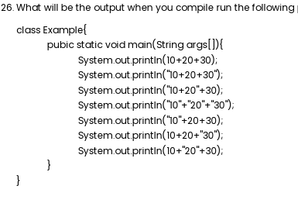
- (pubic) must be public.

Q27.
Code –
class Q27{
public static void main(String args[]){
System.out.println(1+2+3);
System.out.println("1"+"2"+"3");
System.out.println('1'+'2'+'3');
System.out.println('1'+" "+'2'+" "+'3');
System.out.println('A'+'B'+'C');
System.out.println("A"+"B"+"C");
System.out.println('A'+100+200);
System.out.println('A'+" "+'B'+" "+'C');
}
}

Output-
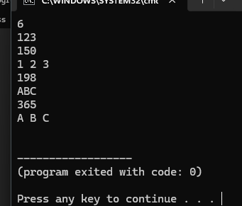
- Line 1 - operator performs standard mathematical addition: $1+2+3=6$.
- Line 2 - that ("1"+"2"+"3") prints in string format
- Line 3 - getting values from ASCII table and adding together
- Line 4 – because of space character(“ ”) it print in string format
- Line5 – getting value from ASCII table and prints value
- Line6 – its print in String format
- Line7 – getting Value from ASCII table for A and adding values and print
- Line8 - because of space character(“ ”), it print in string format
Q28.
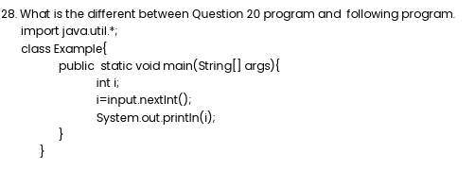

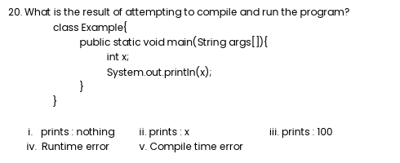

Explain –
- Both are error but in 28 question there is a import java libraries .

Q29.
Code –
import java.util.Scanner;
class Q29{
public static void main(String args[]){
Scanner input = new Scanner(System.in);
System.out.print("Enter the 1 st number : ");
int firstNum = input.nextInt();

System.out.print("Enter the 2 nd number : ");
int secondNum = input.nextInt();

input.close();

int sum = firstNum + secondNum;
System.out.print(firstNum+" "+"+"+" "+secondNum+" "+"="+" "+sum);
}
}
Output-
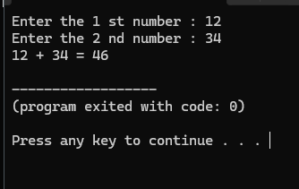

Q30.
Code –
import java.util.Scanner;
class Q30{
public static void main(String args[]){
Scanner input = new Scanner(System.in);
System.out.print("Enter a number : ");
int num = input.nextInt();

String strConcat = ""+ num + num + num;
System.out.println(strConcat);

int aricAdd = num+num+num;
System.out.print(aricAdd);
}
}

Output-
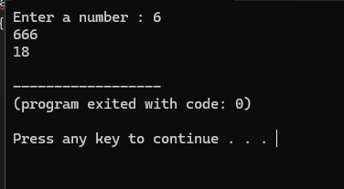

Q31.
Code –
import java.util.Scanner;
class Q31{
public static void main(String args[]){
Scanner input = new Scanner(System.in);
System.out.print("Combined Maths - ");
int cMaths = input.nextInt();

System.out.print("Chemistry - ");
int chem = input.nextInt();

System.out.print("Physics - ");
int phy = input.nextInt();

System.out.print("English - ");
int eng = input.nextInt();

int sum = cMaths + chem + phy + eng ;

System.out.println("Total - " + sum);

}
}

Output
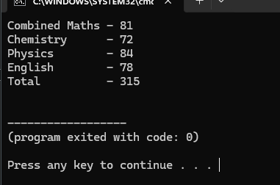
Q32.
Code –
import java.util.Scanner;
class Q32{
public static void main(String args[]){
Scanner input = new Scanner(System.in);
System.out.print("Enter Red value : ");
int red = input.nextInt();

System.out.print("Enter Green value : ");
int green = input.nextInt();

System.out.print("Enter Blur value : ");
int blue = input.nextInt();

int redInv = 255 - red;
int greenInv = 255 - green;
int blueInv = 255 - blue;

System.out.println("Inversion of given colour - " +"["+redInv+","+greenInv+","+blueInv+"]");

}
}
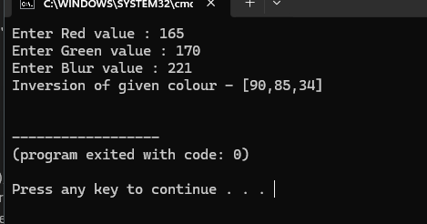

Q33.

Data type | Size | Description
byte | 1 byte | -128 to 127
short | 2 bytes | -37 768 to 32 767
int | 4 bytes | -2,147,483,648 to 2,147,483,647
long | 8 bytes | -9,223,372,036,854,775,808 to 9,223,372,036,854,775,807
flout | 4 bytes | Stores fractional numbers. Sufficient for storing 6 to 7 decimal digits.
double | 8 bytes | Stores fractional numbers. Sufficient for storing 15 decimal digits.
boolean | 1 bit | Stores true or false values.
char | 2 bytes | Stores a single character/letter or Unicode values (0 to 65,535).

Q34.
- new – Not Valid.
- @name – Not Valid.
- user-input – Not Valid.
- My Variable – Not Valid.
- 123num – Not Valid.
- java.org – Not Valid.

Q35.
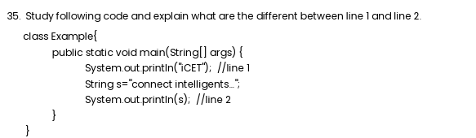

Explain
- line 1- it is print a statement without creating a variable
- line 2 – it is print a variable

Q36.
import java.util.Scanner;
class Q36{
public static void main(String args[]){
Scanner input = new Scanner(System.in);
System.out.print("Whats your name : ");
String name = input.next();
input.nextLine();

System.out.print("Hello "+ name+","+" "+"nice to meet you!");
}
}

Output-
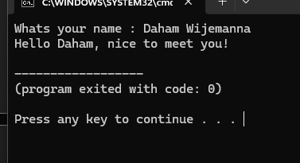

- i use the (.next) method because i wanted to get first name only.

Q37.
Code.
class Q37{
public static void main(String args[]){
int x =10;
int y = 5;
String z = x +'y'+"y"+ x + y +'z';
System.out.println("Z is: " +z);
}
}

Output-
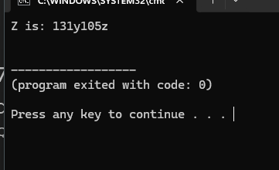

Problem – all given Answers are incorrect

Q38.
import java.util.Scanner;
class Q38{
public static void main(String args[]){
Scanner input = new Scanner(System.in);
System.out.print("Enter your friends name: ");
String name = input.next();
input.nextLine();

System.out.print("Enter your friend's age: ");
String age = input.nextLine();

System.out.print("Enter your friend's living place: ");
String place = input.nextLine();

System.out.print(name+" is my best friend. He is "+age+" years old and lives in the beautiful town of "+place+".");

}
}

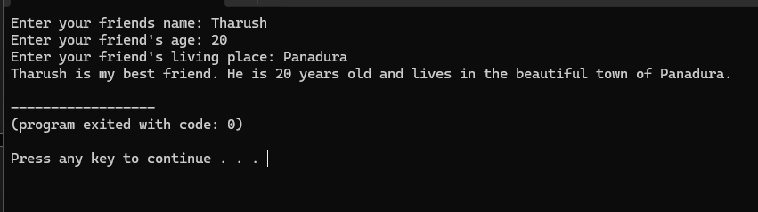

Q39.
Code –
import java.util.Scanner;
class Q39{
public static void main(String args[]){
System.out.println("----Subject total calculator----");
System.out.println();
Scanner input = new Scanner(System.in);
System.out.print("Subject 1 name - ");
String sub1 = input.nextLine();
System.out.print(sub1+" marks - ");
int s1M = input.nextInt();
input.nextLine();
System.out.print("Subject 2 name - ");
String sub2 = input.nextLine();
System.out.print(sub2+" marks - ");
int s2M = input.nextInt();
input.nextLine();
System.out.print("Subject 3 name - ");
String sub3 = input.nextLine();
System.out.print(sub3+" marks - ");
int s3M = input.nextInt();
input.nextLine();
System.out.printf("%-10s"+" %15d\n",sub1,s1M);
System.out.printf("%-10s"+" %15d\n",sub2,s2M);
System.out.printf("%-10s"+" %15d\n",sub3,s3M);
}
}
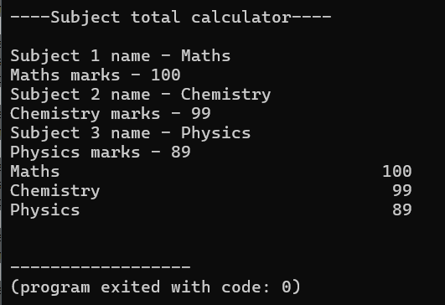
Q40.
Code-
import java.util.*;
class Q40{
public static void main(String args[]){
Scanner input = new Scanner(System.in);
System.out.print("Input number 1 : ");
int num1=input.nextInt();
System.out.print("Input number 2 : ");
int num2=input.nextInt();
System.out.println(num1+" "+num2);
int temp1 =num1;
int temp2 =num2;

num1=temp2;
num2=temp1;

System.out.print(num1+" "+num2);

}
}
